Website development – Landing page
Following the first stage of AI learning and development, there has been some great progress in our thinking relating to the needs of the landing page, particularly following the team presentations. With so many great ideas, it is helpful at this stage to narrow down our needs into a single version for completion.
Website design notes:
1. On brand – The website should use PCS colours, fonts and design assets (as appropriate e.g. when representing the PCS stages). It should have the same fun, and engaging feel as the resources, making it clear that this platform is intended for a school audience.
Colours:
PCS Navy #204969
PCS Blue #009ADE
Inspire Green #00BBB4
Investigate Yellow #FFC557
Act Red #FF595A
Fonts:
Headers - Gilroy Bold (-12 letter spacing)
Body - Century Gothic Regular
Design Assets: add link
2. Images should be in full colour, and should use real pictures from the Common Seas image bank. add link
3. Text on top of images should have a block or text box background. As the block background has been more difficult to prompt, it might be worth selecting the text box approach going forward, but keeping any text overlays to a minimum.
4. AA compliance for accessibility. It is vital to maintain contrast ratios and screen reader accessibility throughout the page. This will also be important to allow machine translation.
5. Translation – it would be ideal if the website translates based on location of the user. The core languages that need to be accurately translated on every page include: English, Greek, Dutch, French, Indonesian. We will need to add to this list in the future.
6. No moving assets/animations except button press indications. Any videos will be lazy-loaded ‘click to view’ ensuring lower bandwidth needs are met.

LANDING PAGE (Home Page) LAYOUT
Nav bar
PCS Logo Home Resources Inspiration Map Sign up/login [language]
Hero image
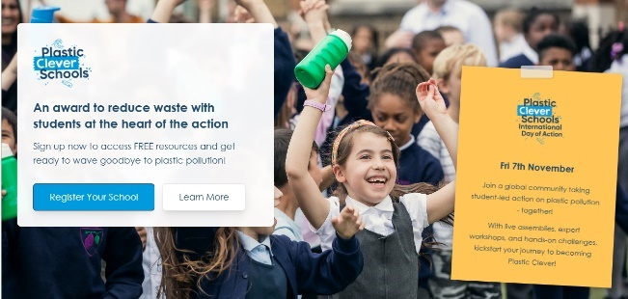
Text box on top
Text box:
Plastic Clever Schools
Working together to wave goodbye to plastic pollution

[Button: Register Your School]

POP UPS – use a post-it note style addition on the hero image to share any recent news or events. This should work on both desktop and mobile.

IMPACT Ribbon (pulls numbers from database – Amy’s example)
X schools | Y countries | Z actions taken [taken from database evidence submitted]
Teacher testimonial (James’s example)  “PLASTIC CLEVER SCHOOLS IS THE BEST…”  Teacher name and photo? |  |  | At launch: What is Plastic Clever Schools? Video.  [embed click to play youtube video- PCS Trailer]  [JS: Recommend adding an opening from the quoted teacher to this video and then using their image as the video placeholder for lazy loading. It’ll look good regardless of whether people watch the video]
INSPIRE [Icon]  Learn about plastic pollution and inspire others in school to take action. | Investigate [Icon]  Identify any problem plastics in school and make a plan to tackle them |  |  | Act [Icon]  Take action to wave goodbye to single-use plastics.

INSTAGRAM LINK – Lizzie idea.

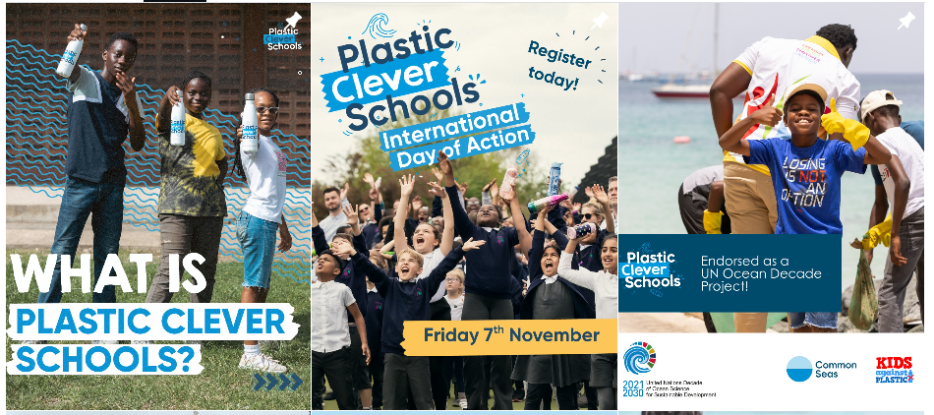

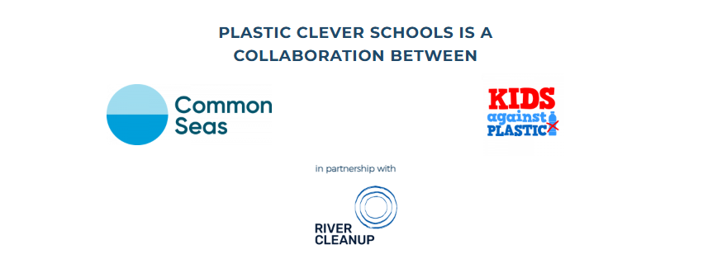 |  | 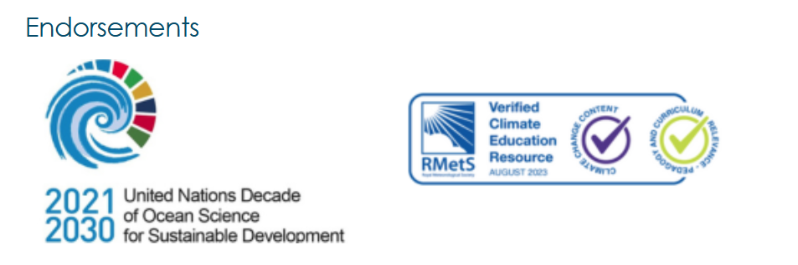
Website footer – what do we need here James?

